# Considered Topologies

In order to satisfy the project specifications, we have considered using three phase diode rectifier with buck converter, single phase thyristor rectifier or three phase thyristor rectifier.

## Three Phase Diode Rectifier with Buck Converter

This topology can be explained under two parts. First part is three phase diode rectifier. Basically, it converts the input AC voltage to output DC voltage. It will be useful in the project as it can take grid AC voltage as input and give DC voltage with decreased ripple as output.

# Drawing

Figure x. Three Phase Diode Rectifier Layout

The output voltage of this rectifier with respect to input line to line voltage can be calculated by:

$$V_{av}=\frac{3\sqrt{2}}{π}V_{ll}$$

Second part is buck converter. The layout of a buck converter can be observed in figure 2. It gets DC voltage as input, rectifies it according to the duty cycle and gives the rectified DC voltage as output. The output voltage can be calculated by:

$$V_{out}=V_{in}*D$$

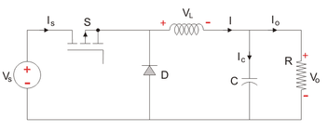

Figure x. Buck Converter Layout

## Advantages

* Three phase diode rectifier takes grid AC voltage as input and give DC voltage with **decreased ripple** as output.
* Even though it consists a rectifier and converter, this topology is less expensive than the topologies that contain thyristor.
* Only one component needs a gate signal so the layout and synchronization is much simpler than the thyristor containing topologies.
  + 1. Disadvantages
* This topology is not suitable for operating in inverter mode.

## Single Phase Thyristor Rectifier

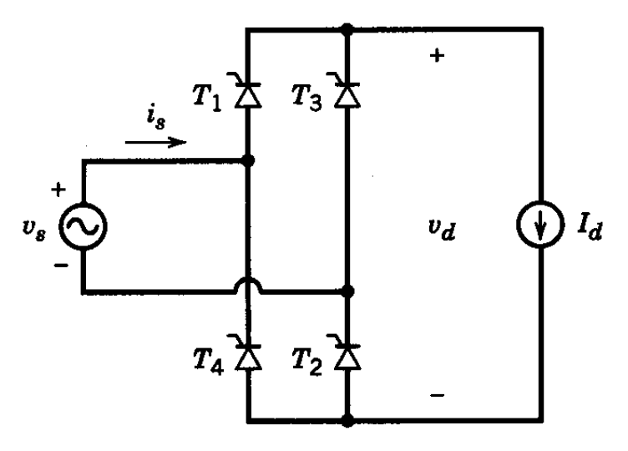

Figure x. Single Phase Thyristor Rectifier Layout

The output voltage of this rectifier with respect to input line to line voltage can be calculated (takin α as the firing angle) by:

* + 1. Advantages
* It contains four thyristor so it is less expensive comparing to the three phase version.
* Since it has four thyristors, circuit layout and gate signal synchronization is simpler than the three phase case.
* It can operate in inverter mode.
* The output voltage can be fully controlled because via the firing angles.
  + 1. Disadvantages
* It costs higher than the three phase diode rectifier with buck converter.
* The output voltage ripple is high.
* The average output voltage is lower than the three phase version.
* In order to drive the thyristor without problem, driver circuits are needed. This increases the layout complexity and costs extra components.

## Three Phase Thyristor Rectifier

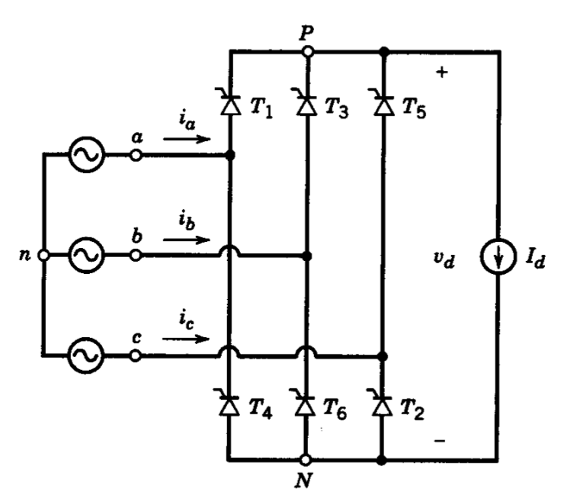

Figure x. Three Phase Thyristor Rectifier Layout

The output voltage of this rectifier with respect to input line to line voltage can be calculated (takin α as the firing angle) by:

* + 1. Advantages
* This topology results in a lower output ripple voltage compared to the single phase case.
* The output voltage is fully controlled.
* The average output voltage is higher.
* It is possible to use this topology in the inverter mode.
  + 1. Disadvantages
* Since six thyristors are used, it is expensive.
* The as the thyristor number increases, gate signal complication increases as well.
* Synchronization and simplification is harder.
* The gate signals of thyristors should be given through drivers. This increases the complexity and cost.

# Topology selection

After analyzing all the advantages and disadvantages of the possible topologies, it is decided to to use three phase diode rectifier with buck converter. While deciding, its low cost and simple driving are considered. Moreover, its output voltage range is suitable for the project specifications.